Tatton Wildlife Newsletter – Winter
Long winter walks in Tatton will provide many health benefits, not only for our physical health, but connecting with our natural surroundings is proven to be beneficial for our mental health too. There is still plenty to see and explore during the winter months out in the parkland.
Birds
One bird that has been seen more often over the past couple of months at Tatton is pictured opposite. This is a ring-necked parakeet. They have been present in the U.K. for many years but are now spreading rapidly. There are many stories surrounding how they managed to establish themselves, some rather fanciful. Ranging from Jimi Hendrix releasing two on Carnaby Street in the 1960’s to birds escaping from the film set of The African Queen in 1951. The most realistic is that during the 1930’s and 1950’s a disease hit captive birds that could pass to humans leading to owners releasing their birds. They are now common in our city parks, and many believe them to be a pest. As hole nesters, they are in direct competition with our native species. This photograph was taken in a local garden by a member of the Knutsford Ornithological Society.
Coppicing Work
Winter is the time of year that we undertake our coppicing work in Millennium Wood. The stand of Hazel close to the gate is managed as a small coppice on a 5/6-year rotation. This is one of the earliest known forms of managing woodlands and involves cutting broadleaf trees down to the ground at regular intervals (from 5 to 25 years, depending on the species and its desired use). New shoots will sprout up from the cut stump, eventually providing manageable straight poles. We use these within Tatton primarily for hedging stakes, bean and pea sticks but other uses including hurdles and fencing materials.
One of the added benefits of coppicing within a woodland is that it promotes biodiversity. There will always be areas (or coupes) of coppice at different stages to provide habitat for a range of wildlife.
Butterfly Survey
After a slow start, this years’ butterfly survey proved interesting, with generally increased numbers and a couple of new species. A total of twenty-one walks were undertaken, opening on 1st April with two comma being the first recorded species, and closing on 14th October with comma, red admiral and speckled wood being the last to be seen on transect. A total of 1,945 individuals were recorded this year, up from 770 in 2022, the most productive day being 24th June when 381 butterflies were seen. Meadow brown made up most of the overall total with 1,095 individual recordings made, followed by gatekeeper (375) and ringlet (164).
Most species did show increases on last year, although only one individual small copper was seen this time and sadly painted lady was totally absent, although a single butterfly was seen off transect on 29th October. After several years of being seen off transect, the common blue finally graced a couple of our walks and 4 individuals were seen. We are also confident that we have got Essex skippers mixed in with our resident small skipper population, which would take the species list up to a respectable 20.
Deer
The deer have now finished the rut and moulted into their winter coats. The hairs of which are hollow allowing it to hold air which warms up and acts as insulation. They are now fed by the ranger team most days with carrots, and haylage when needed, if the weather gets colder. 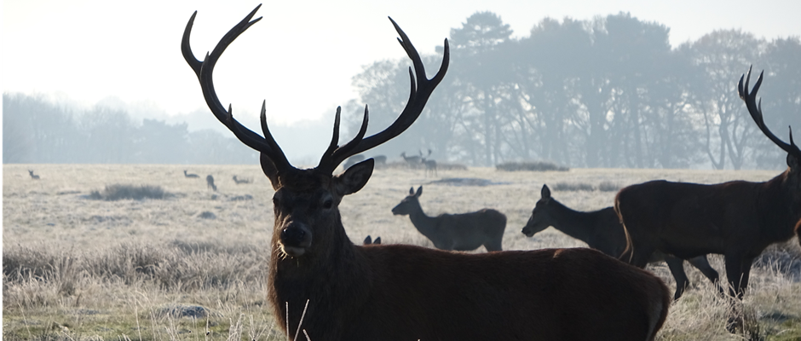Compiled by Tatton’s Ranger Team

